This program that I have written allows users to obtain statistical information on raw or Excel data, information such as the average, median, Standard Deviation, etc. The program has timer functionality built in so if new data is not entered within a fixed time the current recorded statistical information is reset(so as to not merge with new data).

**Before Running please add the poi-4.0.0 jar file provided to the Java build path.**

**How raw data is entered:**

When the program is run, and the raw data option is selected you will be greeted by this menu:

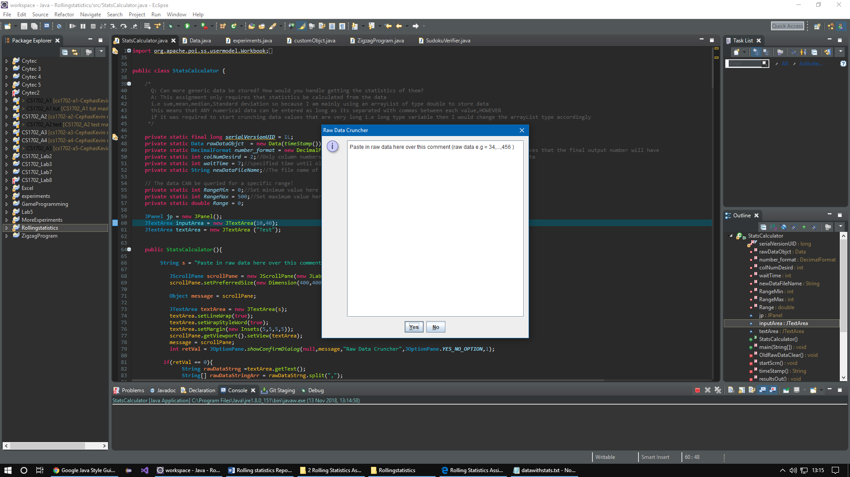

Just to be doubly clear ,raw data must be entered like so:

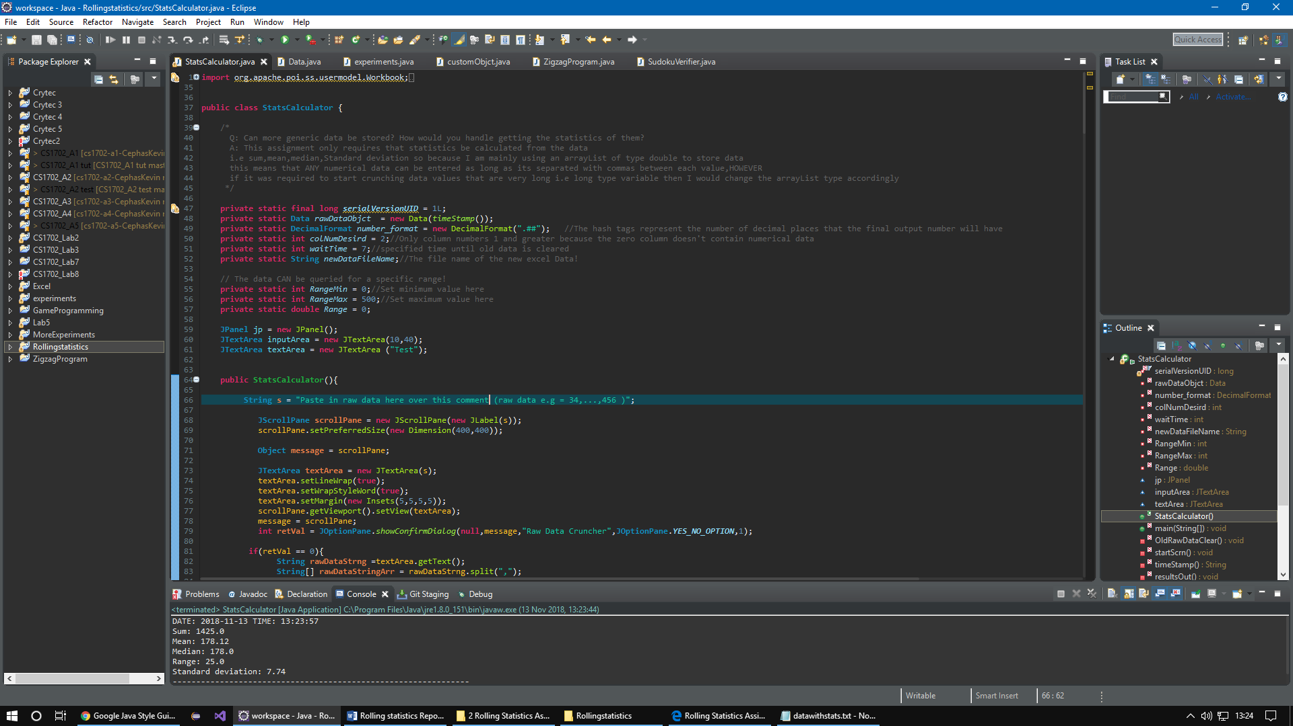 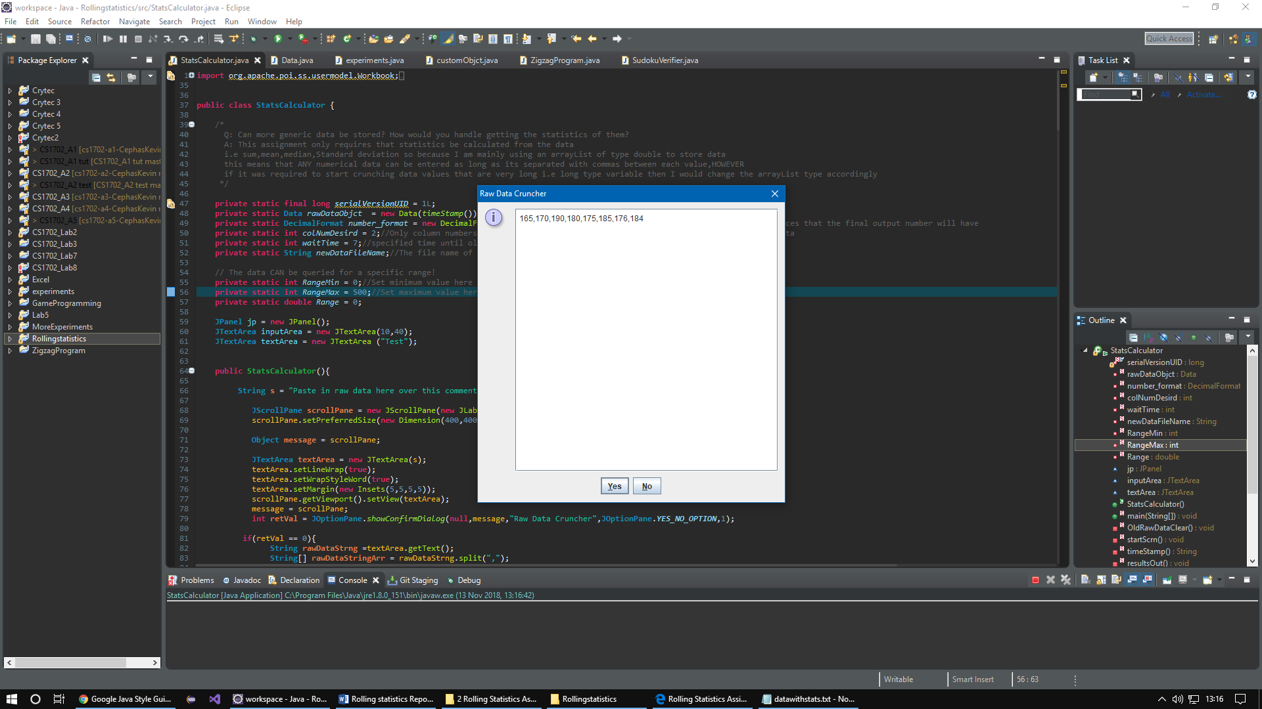

Results output:

Once entered hit ‘Yes’ to crunch the data or ‘No’ to revert.